**Submitted by: Ayesha Sajid**

**Submitted To: Sir Zulqarnain**

**Roll Number: 207704**

**Assignment: Oop**

**Topic: C++ program implementing Selection Sort using pointers.**

**Department: Computer Science**

**Semester: 2nd**

**Dated: 7-June- 2021**

**//Selection Sort**

#include<iostream>

#include<conio.h>

#include<stdlib.h>

using namespace std;

class selsort

{

private:

int arr[10],n,ch;

int *ptr;

public:

selsort(); //constructor

void get_data();//function to get data

void show_data();//function to display data

void Aorder(int *,int );// function to arrange data in assending order

void dorder(int *,int );// function to arrange data in desending order

};

selsort :: selsort()

{

cout<<"\n\n*************Selection Sort*************"<<endl;

}

void selsort :: get_data()

{

cout<<"How many numbers you want to enter to arrange in some order (Total numbers) ? \t";

cin>>n;

if(n==1||n==0)

{

cout<<"Oops! Sorry we can not apply any order on only 1 value";

exit(1);

}//if ending bracket

else

{

cout<<"Enter integers :"<<endl;

for(int i =0; i<n;i++)

{

cin>>arr[i];

}//for ending bracket

}//else ending bracket

}//function ending bracket

void selsort :: show_data()

{

cout<<"\nEnter you choice from below options?\n\t1) Enter 1 for Assending order\n\t2) Enter 2 for dessending order";

cin>>ch;

switch(ch)

{

case 1:

{

cout<<"\nOkay! You want the data to be in desending order lets do it...";

Aorder(arr,n);

cout<<"\n\n**************DISPLAY*************"<<endl;

cout<<"\nYour result is ready , here we go... :";

cout<<endl;

for(int i=0;i<n;i++)

{

cout<<arr[i]<<" ";

}

break;

}

case 2:

{

cout<<"\nOkay! You want the data to be in desending order lets do it...";

dorder(arr,n);

cout<<"\n\n*********DISPLAY*************"<<endl;

cout<<"\nYour result is ready , here we go... :";

cout<<endl;

for(int i=0;i<n;i++)

{

cout<<arr[i]<<" ";

}

break;

}

}

}

void selsort ::Aorder(int *ptr,int n)

{

int temp,min;

for(int i=0;i<n;i++)

{

min = i;

for(int j=i+1;j<n;j++)

{

if(ptr[min] > ptr[j])

{

min=j;

}

}

temp = ptr[min];

ptr[min] = ptr[i];

ptr[i] = temp;

cout<<"\n Position of "<<ptr[min] << " is taken by " << ptr[i];

}

}

void selsort ::dorder(int *ptr,int n)

{

int temp,min;

for(int i=0;i<n;i++)

{

min = i;

for(int j=i+1;j<n;j++)

{

if(ptr[min] < ptr[j])

{

min=j;

}

}

temp = ptr[min];

ptr[min] = ptr[i];

ptr[i] = temp;

cout<<"\n Position of "<<ptr[min] << " is taken by " << ptr[i];

}

}

int main()

{

selsort obj;

obj.get_data();

obj.show_data();

getch();

return 0;

}

// Sorting order program by Ayesha Sajid

Output of selection sort in Ascending order

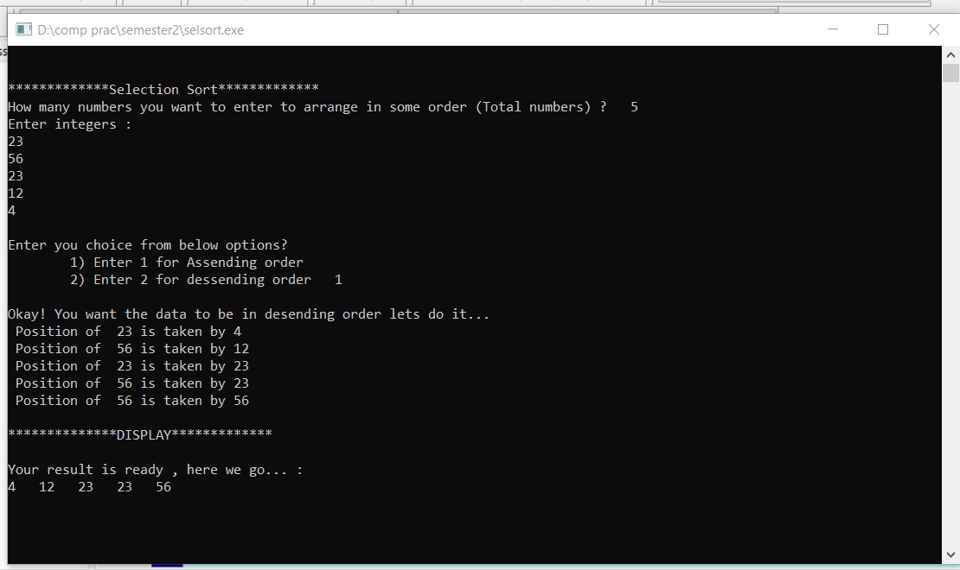 Output of selection sort in Descending order.

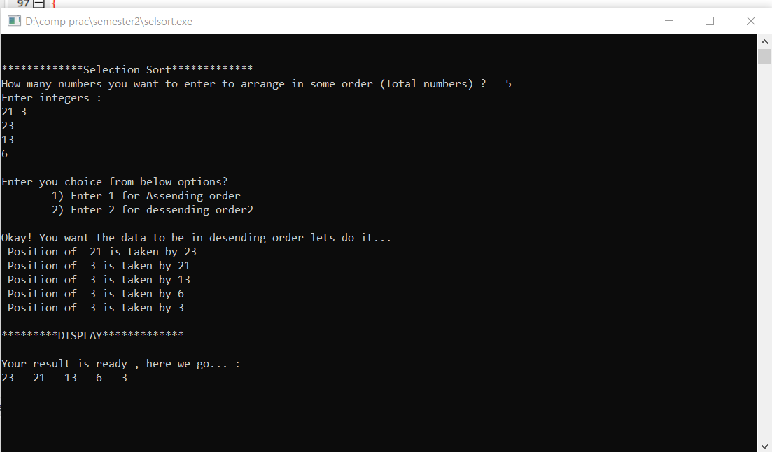

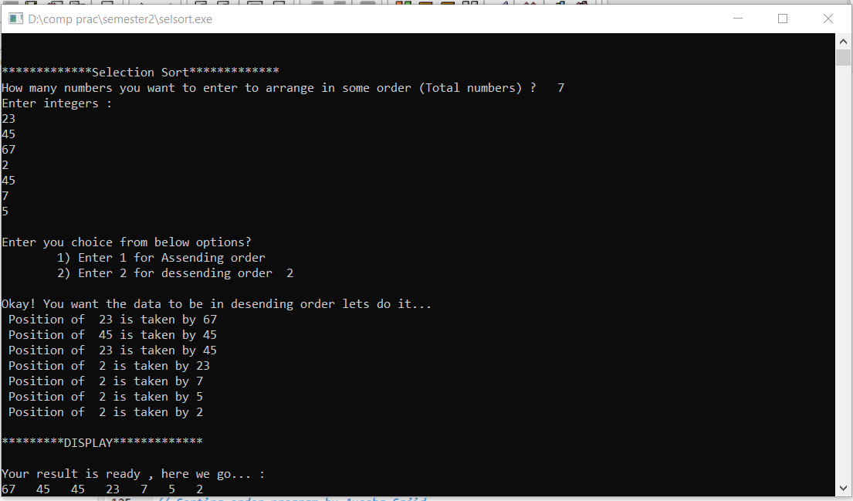

Output of selection sort for single input

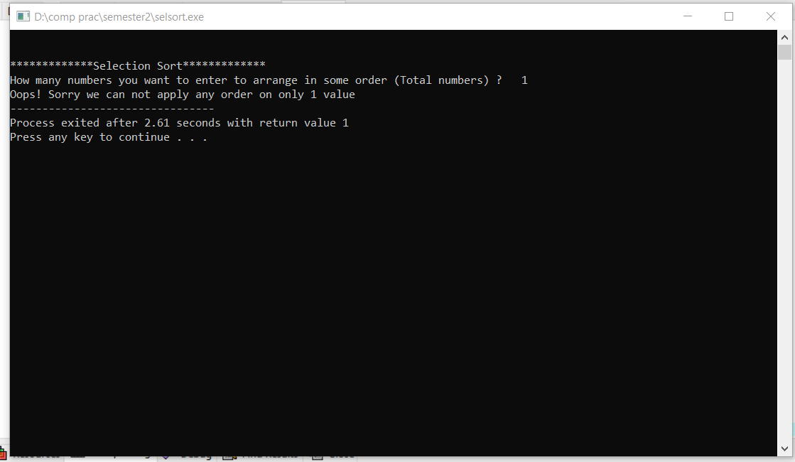

Selection Sort program using pointer in cpp.